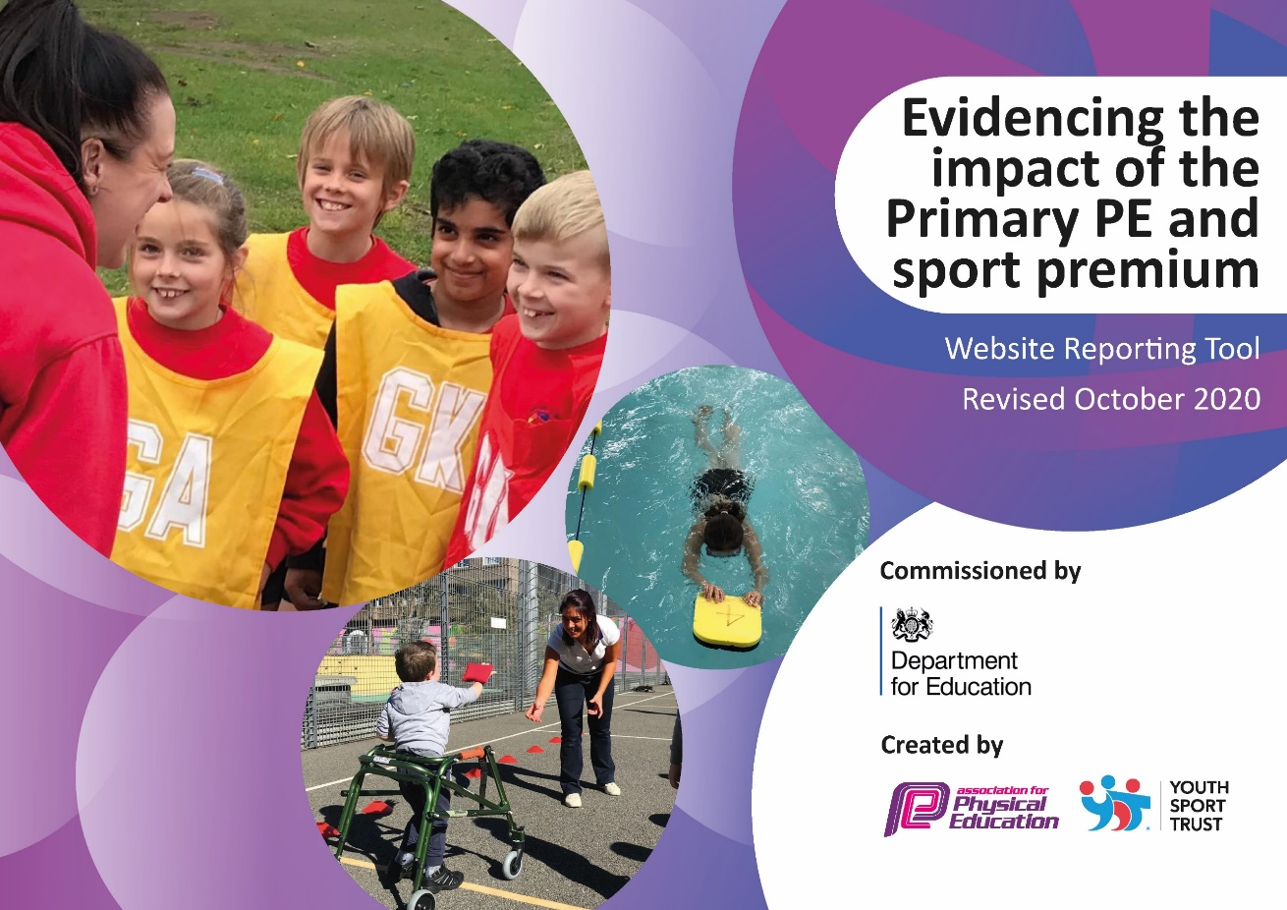
Long Knowle Primary PE Funding allocation: 2022 2023

In Wolverhampton child obesity is above the national average with 40 per cent of year six children in the city classified as overweight or obese according to the latest statistics.

At Long Knowle we want our children to enjoy a wide range of high-quality physical activities and school sport that will promote a life-long love of participating and enjoying activity into adulthood. Our aim is to ensure that our children have at least 30 minutes physical activity per day, alongside their weekly PE lessons. We know the importance that physical activity can have to support a child’s physical and emotional, as well as promoting good well-being. Our curriculum provides a balance of individual and team-based sports, as well as problem solving co-operative games. Children also have the opportunity to be competitive as part of inter school competitions and as part of various Wolverhampton sports leagues. Our activities cater for a wide range of pupil’s differing needs and abilities and strive to develop self-confidence in a range of different activities.

Swimming and Water Safety
Year 6 ending Summer 2022

Meeting national curriculum requirements for swimming and water safety.

N.B Complete this section to your best ability. For example, you might have practised safe self-rescue techniques on dry land.
What percentage of your current Year 6 cohort swim competently, confidently and proficiently over a distance of at least 25 metres?  N.B. Even though your pupils may swim in another year please report on their attainment on leaving primary school at the end of the summer term 2022. | 67%
What percentage of your current Year 6 cohort use a range of strokes effectively [for example, front crawl, backstroke and breaststroke]? | 73%
What percentage of your current Year 6 cohort perform safe self-rescue in different water-based situations? | 70%
Schools can choose to use the Primary PE and sport premium to provide additional provision for swimming, but this must be for activity over and above the national curriculum requirements. Have you used it in this way? | No

Sport Premium Funding

Key Indicator 1: The engagement of all pupils in regular physical activity – Chief Medical Officers guidelines recommend that primary school pupils undertake at least 30 minutes of physical activity a day in school

Key indicator 2 The profile of PE and School sport and activity being raised across the school as a tool for whole school improvement

Key indicator 3 Increased confidence, knowledge and skills of all staff in teaching PE and sport

Key Indicator 4 Broader experience of a range of sports and activities offered to all pupils

Key Indicator 5 Increased participation in competitive sport

Hearty Lives Wolverhampton (source BHF website)
In Wolverhampton child obesity is above the national average with 40 per cent of year six children in the city classified as overweight or obese according to the latest statistics.
As the above statistics show, the rate of obesity of children in Wolverhampton is above the National average, therefore the main focus for Long Knowle children this year is to build on the development of the playground areas. This is to increase the active play that children experience across the school day. The development of our playground markings will encourage active play through increased engagement with physical activity and playing with others. Where possible the activity will link to other areas of the curriculum.

Sports premium allocation for 2022-2023 is £17760

Key achievements to date until July 2023: | Areas for further improvement and baseline evidence of need:
Long Knowle have increased engagement in physical activity across all year groups. The profile of PE and school sport has been raised through intra and inter competitions. Also, we have created a wide range of extra curricular clubs for children from Reception through to Year 6 to attend. These include: football, cricket, rounders, multi skills, netball, tag rugby, family fitness club (parents join children in school for family fun games!), multi sports and basketball.  We have trained 10 Year 5 children to become playground leaders and they have delivered lunch time clubs to Reception through to Year 6. Every year group has a weekly slot to participate. In addition to this, we have trained up 10 new Year 4 playground leaders who have shadowed the Year 5 leaders. They will attend training next academic year.  We have revamped our long term overview for PE lessons and have worked closely with our PE provider to make sure these are being delivered.  We had several children reaching the City Athletics Finals for various events including high jump, long throw, obstacle race for boys and girls and the girls relay.  Our mixed netball team came third in Wolverhampton and advanced ot the Black Country Finals. They reached the semi finals across the entire Black Country!  We have had 3 children represent the Wolverhampton District for football at Under 10s.  The Wolverhampton Association for Sport in Primary Schools (W.A.S.P.S - ) have recognised Long Knowle’s increased participation in Sport by awarding us the ‘Wolf Award’.  Our PE lead has completed the application for the school games mark. We were aiming for Bronze and we have been awarded Gold by our local SGO.  Wild Tribe has been running since February 2022 and has enabled children to access outdoor activity and learning.  One of our Year 6 girls has impressed in Netball and will be representing Wolverhampton next year. | - 10 Year 4 leaders to attend playground leader training in Year 5.  - Continue to offer a range of sporting extra-curricular clubs to ALL.  - Continue to enter a range of sporting event and competitions across the city.  - Monitoring of PE lesson to ensure high quality teaching and learning across the school – led by the PE Co-Ordinator.  - Purchase PE equipment – especially for gymnastics in the hall. Top up existing equipment such as cones, markers, bean bags, quoits, cricket windballs and tri-golf sets.

Key Indicators | School focus and actions  The engagement of all pupils in regular physical activity – Chief Medical Officers guidelines recommend that primary school pupils undertake at least 30 minutes of physical activity a day in school. | Funding allocated | Targets and impact
1 | On return in September: the children will have access to the playground markings on the playground of all key stages.  At break times and lunch times, the children will be encouraged to use the markings, and this will be further developed with the use of targeted in school competitions for the children to achieve “Daily Mile” incentives to complete throughout the week and also to have a monthly winner of the fastest completion of the trails on the playground. (To begin in the Spring term)  Training in the spring term of the lunch time staff to encourage use of the playground markings and recording of timings using equipment.  Further purchases of equipment for use on the playground to encourage  Continued use of the sports coaches to promote structured play and game activities on the key stage one play areas to promote social interaction. | Sport coaches x2 2 hrs per week  £2100  Equipment purchased  £1000  Purchase stop watches for timings across key stages  £100 | All children will participate in at least one hour a week PE slot with additional extra spread out over every half term.  Lunchtimes and playtimes will see increased activity due to fixed equipment being available for children to use. Lunch time staff and sports coaches to encourage children to make use of the markings and develop greater engagement. Friendly inter school competition will engage children to actively use the playground markings.  Sports leaders will successfully engage children on activities during lunch times.
Review and suggested next steps: (reviewed at the end of summer term 2)
Sports leaders have been engaged in delivery of activities across key stage 1. There have been some purchases of equipment for the playground areas but the development of mini competitions has not materialised.
The focus in the new academic year is to develop the key stage two activities and ensure that the lunch time staff have access to the resources to develop playground games. It may also be that the sport coaches develop activities for key stage two rather than key stage one.

Key Indicator | School focus and actions  The profile of PESSPA being raised across the school as a tool for whole school improvement.  Increased confidence, knowledge and skills of all staff in teaching PE and sport | Funding allocated | Targets and impact
2  Key Indicator 3 | All Children to receive 2 hours of PE per week. All children to participate in active lessons across the curriculum. During the year we intend for children to attend school in PE clothing to minimise disruption. Families are happy with this moving forward and it is likely to remain beyond COVID.  Timetable sessions for all year groups. Staff supported by specialist PE staff to deliver high quality PE lessons.  Provide opportunities for enrichment INSPIRE days with sports coaches and invite parents to take part in enrichment activities to encourage family participation.  Sports clubs to continue to take place through the support of TA staff including: cricket, netball, cross country and rounders.  Introduction of other sports to support wide variety of participation within sport: eg possibly cheer leading and children’s yoga.  Attendance on the ConnectEd training for developing a PE curriculum to begin in January. Member of staff to work alongside PE coaches to develop robust and consistent approach to the teaching of PE across the school.  PE lead teachers to have time to develop the strategic direction of PE within school moving forward. Time to develop robust teaching plan that builds on skills and knowledge in sport and physical activity. | Sports coaches x2  £20,000 (Cost covered outside sports premium)  School TA staff £500  Supply teaching budget for cover  £1000 | Pupils’ enjoyment of PE is improved, and children enjoy participating in physical activity. Children will be able to explain why sport and activity is important for a healthy lifestyle.  Parents will be actively engaged in their children’s activity. It provides an opportunity for adults and children to work together.  Staff will be up skilled in order to deliver an effective PE curriculum. They will follow and use a comprehensive scheme for PE that is well planned and builds on the knowledge and skills from previous year groups.
The INSPIRE workshops did not take place this year. The number of staff absence made this difficult to work and so they did not take place. These will be reinstated for the Autumn term 2022 and into Spring term 2023. The sports club offer included football for both boys and girls and also netball clubs. There were opportunities for cross country and also rounders and cricket. The girls' football were runners up for the city and the mixed netball were city champions and went through to the Black Country netball finals and came 3rd. We hope to build on the offer this year with more opportunities to play sport. The new DHT has offered to lead football and so years 3 and 4 will have the opportunity to use the sports coaches after school to play a variety of sports through multi skills.
The ConnectEd trainng did not take place. The school were involved in activities connected to the Commonwealth games and carried a Wolverhampton baton from our school to the next.
In the new academic year, the school curriculum offer will be reviewed and discussed with our sport provider Soccer 2000. This will be to ensure that a more balanced offer is provided for Long Knowle children moving forward.

Key Indicator | School focus and actions  Broader experience of a range of sports and activities offered to all pupils | Funding allocated | Targets and impact
4 | We will use the sports coaches to develop INSPIRE enrichment days and focus days to encourage participation in sports not usually covered by the NC for PE EG archery. Encouraging parents to participate with their children for the benefit of physical activity.  Engage with the WASPS Wolverhampton group to engage in as many sports as possibility within the LA.  Development of a forest school area within the school to engage the whole school in outdoor activities: this will include the training of staff to deliver forest school activities, the development of the area including a shelter and materials.  Purchasing of resources to support the ethos of forest schools. | £500 sport coaches  Staff training £864  Forest school resources  £12,000 | To introduce children to a variety of sports not currently delivered through our NC provision. Children excited to learn new sports.  To engage children across school in outdoor learning that will help to increase confidence and wellbeing as well as the development of structured risk taking, resilience, creativity and increased independence.
As stated, the INSPIRE sessions did not take place due to staffing and COVID related impact. The sports coaches were still used but not with parents attending. The involvement with WASPS has been successful and the children enjoyed success in football and netball. Engaging our children in further sports such as cricket and rounders next year is a target. We did attend Commonwealth Games related sporting activities within year 5, however the cost of transport prevented another year group from taking part.
£10,000 was spent in landscaping and developing the forest school area for early years. They removed trees, put up fencing and landscaped using different coverings on the ground cover. It has started to be used with the early years children but not been developed with older children. The aim is to build up to delivering group sessions across the school. Further staff training is required to enable this to happen.

Key Indicator | School focus and actions  Increased participation in competitive sport | Funding allocated | Targets and impact
5 | Aim to provide all children to participate in a competitive sports activity across the year.  Children to participate in local authority-based competitions as much as possible. Use of WASPs sports network and through ConnectEd partnership.  Provide opportunities for school PE sessions to have a competitive focus – development by sports coaches and school staff. Once per term set up a class based competitive based competition focusing on skills learned over the year.  Sports day opportunity for each key stage for children to experience competitive sports. Sports kit purchased to enable children to represent the school. | Not allocated due to COVID  Sports kit purchase  £549 | Children of Long Knowle will participate in a wide range of sports, taking part in leagues from across the authority as well as inter based sports competitions within school.
The school was well represented at WASPS competitions and as has been stated earlier, the school did well in netball and football. We hope to continue to build on this next year. In school competitions need to be developed further and with our review of the curriculum this will become part of the programme delivered.
Sports day was successful across all year groups and well attended by parents. They welcomed the opportunity to be part of the mornings and the children enjoyed having their parents there.
A new sports kit was purchased for the teams to be used across both football and netball. This with the combination of the older kit we have means there is enough kit for children to use across several sports.

